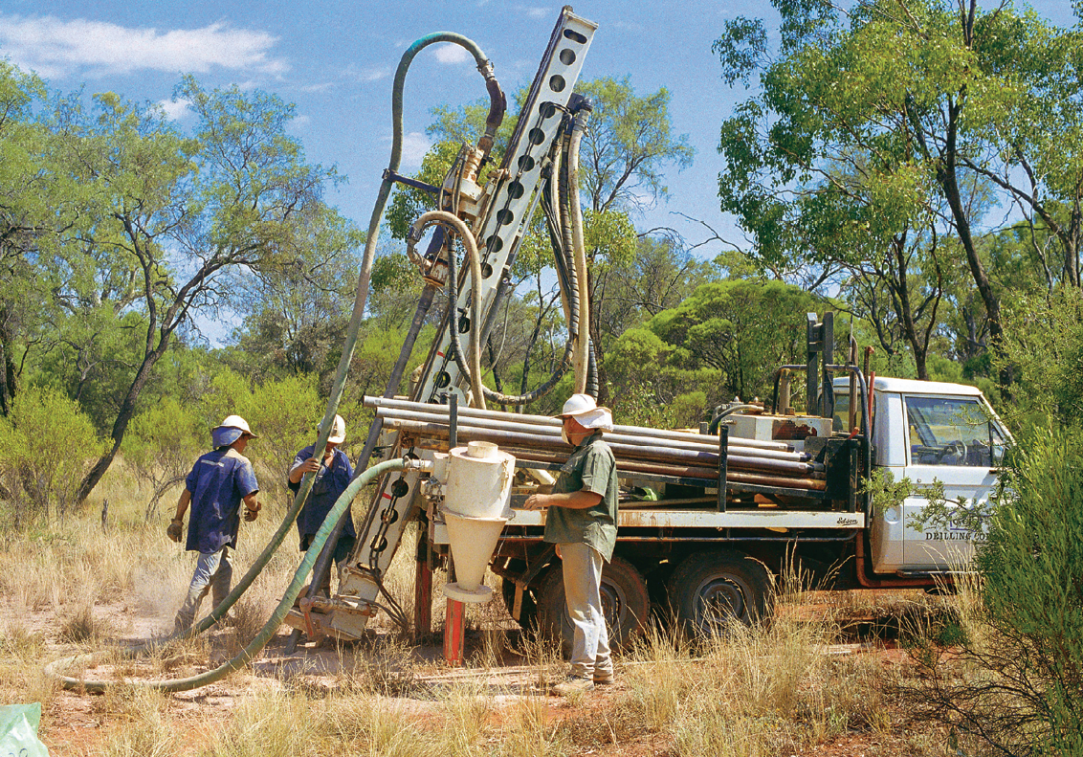

guide | MINING legislation

Exploration reporting: A guide for reporting on exploration and prospecting in New South Wales

Published by NSW Department of Industry, Skills and Regional Development, Division of Resources and Energy
Title: Exploration reporting: A guide for reporting and exploration and prospecting in New South Wales
Cover image: A drilling rig in operation. Source: Geological Survey of NSW Library
Document control
Authorised by: Executive Director, Geological Survey of New South Wales
RM8 Reference: INT16/11360
Amendment schedule
Date | Version # | Amendment
1 November 2010 | 1.0 | First published
1 March 2016 | 2.0 | Updated to reflect legislation amendments and current reporting requirements, data formats and lodgement facilities

© State of New South Wales through the NSW Department of Industry, Skills and Regional Development 2015.
This publication is copyright. You may download, display, print and reproduce this material in an unaltered form only (retaining this notice) for your personal use or for non-commercial use within your organisation. To copy, adapt, publish, distribute or commercialise any of this publication you will need to seek permission from the NSW Department of Industry, Skills and Regional Development.
Disclaimer: The information contained in this publication is based on knowledge and understanding at the time of writing (February 2016). However, because of advances in knowledge, users are reminded of the need to ensure that information upon which they rely is up to date and to check currency of the information with the appropriate officer of the NSW Department of Industry, Skills and Regional Development or the user’s independent advisor.

Disclaimer
The Division of Resources and Energy within NSW Department of Industry, Skills and Regional Development (department) is currently working to produce a revised guideline for mineral and coal geoscientific reporting in NSW, which is expected to be released in the second half of 2016. The department acknowledges that this current guideline may, although providing useful information for NSW explorers and miners, contain inconsistencies in relation to recent legislative amendments to the Mining Act 1992 (the Act) and regulatory amendments to the Mining Regulation 2010 (the Regulations).
If there are inconsistencies between the requirements of this guideline and the requirements of the Act or the Regulations, the Act or the Regulations prevail to the extent of that inconsistency.

Foreword
Comprehensive geoscientific records of mineral and coal exploration and mining provides a major competitive advantage to Australia. Access to reports and data on past exploration and mining ensures that exploration investment does not duplicate past effort and can build on accumulated knowledge. Accordingly, the accurate recording of mineral and coal exploration and mining is mandatory.
The Division of Resources and Energy (the division) within NSW Department of Industry is responsible for acquiring, assessing, storing and distributing this information. The department uses this geoscientific data to inform the government, resource industry and community about the state’s resources, and to facilitate safe and sustainable development of NSW mineral and energy resources for the benefit of all NSW citizens.
This guideline has been prepared according to the Mining Act 1992 (Act) and the Mining Regulation 2010 (Regulation). The Act legislates mineral and coal exploration and mining activities and as well as safety, environmental protection, royalties and compensation. The purpose of this guideline is to specify the format, contents and standards required to prepare and submit geoscientific reports and data.
Geoscientific reports are required under all types of authorities under the Act.
Note: this guideline does not apply to safety, environmental management and rehabilitation, or community consultation reporting.
More information on reporting, submission and archiving of geoscientific reports and data is available on the websites listed below.
Website links for further information
Subject | Division of Resources and Energy website link
Geoscientific reporting | http://www.resourcesandenergy.nsw.gov.au/miners-and-explorers/enforcement/exploration-reporting
DIGS | http://www.resourcesandenergy.nsw.gov.au/miners-and-explorers/geoscience-information/online-services/digs  DIGS® (Digital Imaging Geological System) is a digital reporting and archiving system provided by the DRE to store data and information in digital format. This allows reports and data to be searched for, viewed and printed.
EROL | http://www.resourcesandenergy.nsw.gov.au/miners-and-explorers/geoscience-information/services/online-services/erol  Exploration and Environmental Online Lodgement (EROL) allows title holders to lodge reports and data online. All reports and data lodged are assessed by department geoscientists to ensure compliance with this guideline.

Contacts

NSW Department of Industry
Division of Resources and Energy
516 High St Maitland NSW 2320
PO Box 344 HRMC NSW 2310
www.resourcesandenergy.nsw.gov.au

For further information on this guideline or geoscientific reporting contact:

Geological Survey of NSW
516 High St Maitland NSW 2320
PO Box 344 HRMC NSW 2310
Reporting/service | Unit/company | Contact details
Geoscientific reporting  Coal, geothermal and oil shale  (Groups 8, 9 and 9A) | Strategic Resource Assessment and Advice  - Geological Survey of NSW | Phone: (02) 4931 6689  Email: coal.geology@industry.nsw.gov.au
Geoscientific reporting:  All other mineral groups (Groups 1-7 and 10) | Mineral Exploration Assessment  - Geological Survey of NSW | Phone: (02) 4931 6698  Email: minerals.explorationassessment@industry.nsw.gov.au
Geophysical surveys and geoscience products | Geoscience Information – Geological Survey of NSW | Phone: (02) 4931 6717  (02) 4931 6597  Email: geophysics.products@industry.nsw.gov.au  geoscience.products@industry.nsw.gov.au
DIGS and EROL administration | Geoscience Information – Geological Survey of NSW | Phone: (02) 4931 6556  Email: digs.info@industry.nsw.gov.au
Londonderry Core Library | Geoscience Information – Geological Survey of NSW | WB Clarke Geoscience Centre  947-953 Londonderry Rd  Londonderry NSW 2753  Phone: (02) 4777 0322  Email: corelibrary.admin@industry.nsw.gov.au
Broken Hill Core Library | Geoscience Information – Geological Survey of NSW | E C Andrews Drillcore Facility  42-56 Pinnacle Pl  Broken Hill NSW 2880  Phone: (08) 8087 5143

Contents
Part A: General requirements 1
1. Introduction 1
2. Submitting reports and statistics 1
3. Transitional reporting arrangements 2
4. Tables to accompany reports 2
5. Assessment of reports and data 2
6. Technical manager 3
7. Extensions and exemptions from reporting 3
8. Group reporting (mining authorities only) 4
9. Confidentiality of reports and data 4
10. Cores and samples 4
Part B: Structure of reports 5
1. Annual reports 5
2. Partial relinquishment reports 7
3. Final reports 9
Part C: Tables to accompany reports 11
Part D: Submitting digital data 12
1. Online lodgement 12
a) Digital Imaging Geological System – DIGS® 12
b) Exploration and Environmental Reports Online Lodgement – EROL 12
c) File size 12
d) Large File Exchange Service - LaFix 13
2. File formats for digital data submission 13
a) Reports 13
b) Images 13
c) Geoscientific data (drilling, geochemistry, ground geophysics) 14
d) File naming convention 14
e) Metadata 14
f) Geographical information system and vector data 14
g) Location coordinates 15
h) Airborne geophysical survey data 15
i) Remote-sensed survey data 15
j) Seismic survey data – sections 15
Part E: Templates for data 18
1. Data templates for mineral groups 1-8, 9A and 10 18
2. Data formats for coal (Group 9) 24
a) Coal borehole summary table 24
b) Coal borehole data 24
c) CoalLog standard 24
d) Regional geophysical data (seismic, magnetic, gravity) 25
Part F: Reports for small-scale titles 27
a) Opal prospecting licences 27
b) Explanatory notes for opal prospecting licence drillhole logs 27

Tables
Table 1 Report types 1
Table 2: Summary formats for digital data 17
Table 3 Exploration data templates 18
Table 4 Coal data format example 25

Part A: General requirements
- Introduction
This guideline will assist authority holders in NSW prepare geoscientific reports and data required by the Mining Act 1992 (Act) and the Mining Regulation 2010 (Regulation).
Each report must comply with this guideline and contain all diagrams, plans, and data necessary to satisfactorily interpret and evaluate the report. Reports supplied to the department that provide incorrect or misleading information and/or do not meet all the reporting requirements will be considered unsatisfactory and returned to the author for revision. Data that is incomplete or outstanding can be submitted once received. You must indicate in your submission that there is additional data to come and when it will likely be submitted. The department takes a reasonable approach to incomplete and outstanding data.
- Submitting reports and statistics
Table 1 provides a summary of all report types required, their due dates, mode of submission and the period of confidentiality. All reports and data must be submitted in digital form via the relevant mode of submission and in the specified structure outlined in Part B of this guideline. Accompanying data must also be submitted in the format listed under Parts D and E of this guideline.
The only exception to this requirement is for reports on small-scale operations where there is no requirement for fully qualified technical management: for example Opal Prospecting Licences (OPLs). These reports may be submitted on paper or in digital form. Reports for OPLs should be lodged with the Mining Registrar of the Mining Division in which the claim or licence is situated. Details of reporting requirements for OPLs are located in Part F of this guideline.
Table 1 Report types
Report type | Reporting format | Due date | Mode of submission | Confidentiality period
Annual report (and data) | As specified in Part B, Section 1 of guideline | One calendar month after the grant anniversary date of title | EROL | Reports lodged on or after 1 June 2016 - five years after the report was lodged  Reports lodged before 1 June 2016 – five years from that date (1 June 2021)
Partial relinquishment report (and data) | As specified in Part B, Section 4 of guideline | One calendar month after notice of the part renewal or cancellation | EROL | None - Open File immediately on relinquishment or cancellation
Final report (and data) | As specified in Part B, Section 5 of guideline | One calendar month after the expiry or cancellation of the title | EROL | None - Open File immediately on expiry or cancellation

- Transitional reporting arrangements
Improved Management of Exploration Regulation (IMER) is a reform of NSW exploration regulation, implemented from 1 July 2015. It applies only to exploration licences (ELs) and assessment leases (ALs). For further information about IMER go to: www.resourcesandenergy.nsw.gov.au/miners-and-explorers/codes-and-guidelines/imer.
ELs and ALs where their applications for grant of renewal were lodged on or after 1 July 2015 are called IMER titles and are subject to IMER licence conditions. Those titles that have not been renewed under IMER are called non-IMER titles and will continue with their current licence conditions until their next renewal.
Mining authorities are not covered under IMER and therefore are non-IMER titles.
IMER titles
IMER titles require Annual Activity Reports to be submitted as per the Exploration guideline: Annual Activity reporting for prospecting titles.
Annual Activity Reports contain four components, one of which is the annual (geoscientific) report:
- Annual summary activity and expenditure table
- Annual exploration (geoscientific) report
- Annual environmental management and rehabilitation report
- Annual community consultation report.
IMER titles are also subject to a condition relating to work programs which must be prepared in accordance with the Exploration guideline: work programs for prospecting titles. This requires the submission of the updated work program annually at the same time as an Annual Activity Report, regardless of whether the work program is changing.
Reporting under an Annual Activity Report condition meets requirements of Clause 57 of the Regulation.
Non-IMER titles
Non-IMER titles do not have a condition relating to Annual Activity Reports and therefore must continue to report in accordance with the Regulation and this guideline. Environmental management and rehabilitation reports and community consultation reports may be required in accordance with existing licence conditions.
Non-IMER titles do not have to comply with the Exploration guideline: work programs for prospecting titles and do not have to submit work programs annually.
- Tables to accompany reports
All reports require an Exploration Activity and Expenditure Table to be submitted which provide information in a standard format. The most up-to-date version of this table is available at:
http://www.resourcesandenergy.nsw.gov.au/miners-and-explorers/enforcement/exploration-reporting/mineral
- Assessment of reports and data
Report and data must be lodged online at the Exploration and Environmental Online Lodgement (EROL) website. All reports and data lodged are assessed by department geoscientists to ensure they comply with this guideline. Reports are also assessed to monitor exploration progress, inform decisions on applications for a new title or the renewal of a title, and to ensure that the results of exploration are fully and clearly recorded for the benefit of future explorers and researchers.
Satisfactory reports are accepted and an email notification advising that the report has been assessed and accepted is sent to the email address of the EROL account through which the report was lodged. Satisfactory reports are accepted and archived to DIGS®.
Reports and data that do not meet the requirements of this guideline are deemed unsatisfactory and sent back to the person who lodged the report for amendment and resubmission. In this case, an email notification is sent to the EROL account through which the report was lodged. The notification will include details of why the report was assessed as unsatisfactory and what action is required. Reports or data that require resubmission must be resubmitted within two weeks after the notification date.
- Technical manager
All titles must have a nominated technical manager who is responsible for supervising prospecting operations and (geoscientific) exploration reporting. The person may hold tertiary qualifications in geoscience or mining engineering, or have other qualifications or other relevant and appropriate exploration experience for the commodities sought under the title.
Reports must be verified by the technical manager that the report accurately discloses the nature, extent, timing, results and geological interpretation, and that the activity summary accurately discloses expenditure (if relevant), of the exploration conducted during the reporting period, either by a signature or by making this statement. The name and contact details of the nominated technical manager must be provided in any report.
Approval of the technical manager is given on grant or renewal. The department must be notified of any change in the technical manager within 7 working days and approval sought.
- Extensions and exemptions from reporting
Clause 60 of the Regulation allows for authority holders to apply for an extension of the period within which a report must be lodged, or for an exemption from reporting requirements. However, extensions and exemptions are not generally granted except in cases of extreme hardship.
Applications for extensions or exemptions must be lodged 30 days before the date the report is due using the form Application for extension or exemption from reporting (ER01). Exemption from reporting requirements does not exempt the authority holder from their obligation to fulfil other conditions of authority, especially the requirements to effectively explore, assess or mine the authority area.

- Group reporting (mining authorities only)
Group geoscientific reporting is only available for contiguous mining authorities where they are operated as a single project. Group geoscientific reporting of ELs and ALs is not accepted.
Applications for group reporting must be lodged with and approved by the department in letter format via email to the relevant unit within the Geological Survey of NSW shown under Contacts.
Group reports must provide information on what activities were conducted on each title within the group and contain a separate expenditure table for each title. If a single activity occurs across more than one title a pro-rata distribution of expenditure across those titles is acceptable.
- Confidentiality of reports and data
Clause 58D of the Regulation specifies the timing for release of reports and data:
- In the case of an annual report (and associated data) lodged on or after 1 June 2016, reports must remain confidential for a period of five years from the date the report was lodged
- In the case of an annual report (and associated data) lodged before 1 June 2016, reports must remain confidential for a period of five years since that date i.e. until 1 June 2021.

Partial relinquishment reports and final reports are released once the title ceases to be in force (in most cases immediately).
- Cores and samples
All titleholders must (so far as reasonably practicable) collect, retain, label and preserve all cores remaining after sampling and all characteristic samples of the rock or strata encounted for the life of the title (Clause 58E of the Regulation). Cores and samples must be made available for examination and/or sampling by department officers on request.
The titleholder must not dispose of cores and samples without approval from the department and without first offering them to the department for archival storage. The department will make a decision whether they wish to keep the cores/samples or not. The department’s core libraries contain a selection of representative cores and samples for the benefit of explorers and other researchers.
If directed, the title holder must lodge selected cores and samples with one of the core libraries. Offers of core must be directed in writing to:
WB Clarke Geoscience Centre
Geological Survey of NSW
947-953 Londonderry Rd, Londonderry NSW 2753
Phone: (02) 4777 0322
Email: corelibrary.admin@industry.nsw.gov.au

Part B: Structure of reports
- Annual reports
Annual reports should present the technical results and geological interpretation of exploration activities and/or mining operations carried out during the reporting period.

Reports should explain the exploration philosophy and objectives (e.g. the type of mineral deposit sought and the reasons for considering the area prospective for such deposits). This is particularly important for the first report since it provides a basis for future report assessment and, in particular, determination of exploration progress. Geoscientific data must be provided in accordance with Part D or E of this guideline.
Annual reports must contain:
- Title page (1 page)
- report type (i.e. annual)
- authority number
- authority holder
- grant and expiry dates
- project operator (if applicable)
- project name and location (if applicable)
- the reporting period
- date of report
- author(s) including contact details
- name, contact details and verification by the nominated technical manager.

- Executive summary or abstract (maximum 1 page)
- a summary of all exploration activities and/or mining operations conducted during the reporting period.

- Background (recommended maximum 2 pages of text)
- location and access
- geology
- authority history and previous exploration
- exploration rationale (type of deposit sought and reasons for considering the area prospective).

- Exploration completed in reporting period
- a detailed description of exploration activities carried out within the reporting period only, including full details and results of all studies, surveys, sampling or drilling programs, or other operations conducted
- a scaled diagram/map showing the locations of exploration activities undertaken during the reporting period. The scaled diagram/map should also include the title boundary, towns and major infrastructure (e.g. railways, highways, roads)
- A completed Current Exploration Activity and Expenditure Table
- Where there have been external studies, such as university thesis, or where research papers have been prepared for publication, the main conclusions of those works should be briefly summarised and a reference to the full work provided.

- Results and discussion
- plans, sections and data generated to illustrate the exploration results, any interpretation of results and significance of results, geological models, conclusion reached and recommendations
- Data
- a summary of data being submitted with this report
- a summary of any data which is not being submitted, reasons why, and when and how the data will be submitted i.e. LaFiX

- Proposed exploration in next reporting period (not required for IMER titles)
- a description of the proposed exploration activities and/or mining operations within the next reporting period only
- a standard scaled diagram/map showing the locations of proposed exploration activities. The scaled diagram/map should also include the title boundary, towns and major infrastructure (e.g. railways, highways, roads)
- A completed Proposed Exploration Activity and Expenditure Table.

- Additional requirements for assessment leases (if applicable)
- most recent resource/reserve statement for the deposit (JORC compliant)
- details of metallurgical/washery/processing studies carried out in the reporting period
- details of economic modelling/feasibility studies carried out in the reporting period
- details of marketing studies carried out in the reporting period
- details of any other assessment activities carried out in the reporting period

- Additional requirements for mining authorities (if applicable)
- most recent resource/reserve statement (JORC compliant)
- production statistics for the reporting period including amount of material mined and amount of ore shipped
- a description of current mining operations
- a description of any assessment activities carried out in the reporting period
- a summary of geological findings including the main results of activities conducted in the mine, such as geological, structural mapping and petrological and mineralogical studies. Information on stratigraphy, distribution and controls of mineralisation, alteration features, etc should be included if available

- Partial relinquishment reports
Partial relinquishment reports are required when an authority is reduced in area. The report is essentially a final report only on the part of the authority relinquished. If the current authority has any ‘flow-on’ from a previous authority, all exploration/mining operations completed on the previous authority in the area affected by the current relinquishment must be included. Geoscientific data relating to the area relinquished must be provided in accordance with Part D or E of this guideline.
Partial relinquishment reports must contain:
- Title page (1 page)
- report type (i.e. partial relinquishment)
- authority type and number
- authority holder
- grant date
- partial relinquishment date
- area relinquished (units or ha and % of authority)
- project operator (if applicable)
- project name and location (if applicable)
- date of report
- author(s) including contact details
- name, contact details and verification of the nominated technical manager.

- Executive summary or abstract (maximum 1 page)
- a summary of all exploration, assessment and mining operations carried out during the full term (since grant) of the area being relinquished
- the reason(s) for relinquishment.

- Background (recommended maximum 2 pages of text)
- location and access
- geology
- title history and previous exploration
- exploration rationale.

- Exploration/assessment completed
- a description of all exploration activities carried out on the area being relinquished since the grant of the title
- A completed Current Exploration Activity and Expenditure Table for the full term of the area being relinquished
- a scaled diagram/map showing the locations of all activities carried out in the relinquished area
- an inventory and details of all core and samples collected, their storage locations and plans for future storage.

- Results and discussion
- plans, maps, diagrams and sections that illustrate the geology including plans, sections and data generated to illustrate exploration results, significant of results, geological models, resource/reserve estimates and anything else that may be relevant

- Conclusions and recommendations
- a summary of exploration (or mining) results, including conclusions reached regarding the geology of the area and the resource potential. In addition, where further exploration work may increase the resource potential, recommendations for future exploration should be included.

- Additional requirements for partial relinquishment of assessment leases (if applicable)
- Most recent resource/reserve statement (JORC compliant)
- details of metallurgical/washery/processing studies carried out
- details of economic modelling/feasibility studies carried out
- details of marketing studies carried out
- details of any other assessment activities carried out

- Additional requirements for mining authorities (if applicable)
- production statistics for the life of mine in the area to be relinquished including amount of material mined and amount of ore shipped
- details of the nature of resources grade or quality in mine residue
- a statement of any unmined reserves/resources (JORC compliant)
- an assessment of any future mining potential in the relinquished area
- a summary of the mine geology including stratigraphic details, structure, any petrological and mineralogical studies, distribution and controls of mineralisation, alteration features, etc.
- details of all cores and cuttings from the relinquished area their storage locations
- where there have been external studies, such as university thesis or where research papers have been prepared for publication, the main conclusions of those works should be briefly summarised and a reference to the full work provided.

- Final reports
Final reports are the last reports for an authority and are submitted after the authority has been fully cancelled or relinquished, or expires They will, in addition to all annual reports, be the main source of information for future explorers of the area. Only one final report is written per authority and it may incorporate the last annual report. Any geoscientific data that has not been previously submitted must be submitted with this report in accordance with Part D or E of this guideline.
Final reports must contain:
- Title page (1 page)
- report type (i.e. final)
- authority type
- authority number
- authority holder
- grant date
- cancellation/relinquishment/expiry date
- project operator (if applicable)
- project name and location (if applicable)
- date of the report
- author(s) including contact details
- name, contact details and verification of the nominated technical manager.

- Executive summary or abstract (maximum 1 page)
- a summary of all exploration, assessment and mining activities conducted during the full term (since the grant) of the title.

- Background (recommended maximum 2 pages of text)
- location and access
- geology
- authority history and previous exploration and/or mining
- exploration rationale

- Exploration completed
- a detailed description of any exploration activities carried out during the final year of the authority using templates in Part D and E as appropriate
- a scaled diagram/map showing the locations of all exploration activities undertaken from the grant of the title. The scaled diagram/map should also include the title boundary, towns and major infrastructure (e.g. railways, highways, roads).
- a completed Current Exploration Activity and Expenditure Table for all exploration activities carried out during the term of the authority
- an inventory of all core and samples collected, their storage locations and plans for future storage.

- Results and discussion
- plans, sections maps, diagrams and sections that illustrate the geology including shows, occurrences, resources and reserves where applicable

- Conclusions and recommendations
- A summary of exploration and/or mining results, including conclusions reached regarding the geology of the area and the resource potential. Where further work may increase the resource potential, recommendations for future exploration should be included.

- Additional requirements for assessment leases (if applicable)
- Most recent resource/reserve statement (JORC compliant)
- details of metallurgical/washery/processing studies carried out
- details of economic modelling/feasibility studies carried out
- details of marketing studies carried out
- details of any other assessment activities carried out.

- Additional requirements for PPLs (if applicable)
- production statistics for the life of mine in the area to be relinquished including amount of material mined and amount of ore shipped
- details of the nature of resources grade or quality in mine residue
- a statement of any unmined reserves/resources (JORC compliant)
- an assessment of any future mining potential in the relinquished area
- a summary of the mine geology including stratigraphic details, structure, any petrological and mineralogical studies, distribution and controls of mineralisation, alteration features, etc.
- details of all cores and cuttings from the relinquished area their storage locations
- where there have been external studies, such as university thesis or where research papers have been prepared for publication, the main conclusions of those works should be briefly summarised and a reference to the full work provided.

Part C: Tables to accompany reports
All reports require an Exploration Activity and Expenditure Table to be submitted which provide information in a standard formats. The most up-to-date version of this table template is available at:
http://www.resourcesandenergy.nsw.gov.au/miners-and-explorers/enforcement/exploration-reporting/mineral
This table has two tabs, the first tab is for current exploration activities and expenditure and the second tab is for proposed exploration activities and expenditure. The table must be in PDF format and inserted into the report

Notes for completing Exploration Activities and Expenditure Tables
- office administration can include: office administration, training, rent, security, agents fees, insurance, office equipment and IT/software. Note: this should not exceed 15% of the total
- authority management can include: advertising of EL, report distribution and submission, legal matters, native title management, community liaison, compensation payments and land access
- office activities can include: literature review, data acquisition, data compilation, data processing, research, remote sensing interpretation, report preparation, GIS/cartography, exploration database, prospectivity modelling and resource estimation, exploration planning
- laboratory analysis can include: assays, petrology, isotopes, metallurgy/washability and processing and freight.

Part D: Submitting digital data
- Online lodgement

Digital Imaging Geological System – DIGS®
DIGS® is an online archive that holds reports, publications and other important documentary material held by the department.
The department requires the submission of data in digital format. This allows the department to provide useful non-confidential data to industry, either via data packages or directly from DIGS®.
Digital data provided to the department will be held in the DIGS® system in its native format. Native formats as defined by DIGS® are: PDF, ASCII (TXT, DAT, LAS, CSV), JPG, TIFF and ZIP.

Exploration and Environmental Reports Online Lodgement – EROL
Exploration and Environmental Reports Online Lodgement (EROL) allows titleholders to lodge reports online for verification by the department. A satisfactory report lodged in EROL is submitted electronically to DIGS®.
For more information on how to submit reports (including instructions for applying for a user account) using EROL, refer to the department website:
http://www.resourcesandenergy.nsw.gov.au/miners-and-explorers/geoscience-information/services/online-services/erol
Only the following file types can be submitted using EROL:
- PDF Portable Document Format
- LAS Log ASCII Standard (as zipped files)
- TXT Tab delimited ASCII text file
- CSV Comma delimited ASCII text file
- JPG Joint Photographic Group
- TIF Tagged Image File

Proprietary file formats are not accepted by EROL. In particular, filename.doc (Word), filename.xls (Excel), GIS formats.

For help with using EROL call (02) 4931 6556 or email digs.info@industry.nsw.gov.au.

File size
The maximum limit of a single digital file attached to a report is 32 Mb. Each report can have up to 200 digital files of up to 32 Mb each attached.
If there are a significant number of large files to be submitted (for example, coal drill hole records, ground geophysical survey records), an ‘Offline Data’ option is available to be used.

The report is still loaded onto EROL, but the file is listed as ‘Offline’ and a file description must be supplied.

The file must then be sent to the Department on a CD/DVD within 14 days of the EROL submission. The CD/DVD must be labelled with the EROL submission number, authority number, authority holder and report type. Offline data files must be formatted as for on-line files.
It is preferred that coal borehole data from the same hole are zipped together in zip files under 24Mb.
Each zip file must contain the borehole name and data description.

Offline data must be sent to:
Groups 8, 9 and 9A - Reporting Officer, Strategic Resource Assessment and Advice.
Groups 1 to 7 and 10 – Reporting Officer – Mineral Exploration Assessment.

Postal address is provided under Contacts.

Large File Exchange Service - LaFix
The department’s Large File Exchange Service (LaFiX) is used where data needs to be submitted that exceeds 32 Mb (for a single file) or where there are more than 200 files to attach to a report. The LaFix website link is:
http://www.resourcesandenergy.nsw.gov.au/miners-and-explorers/geoscience-information/services/online-services/lafix
This data is to be submitted in addition to a report submitted via EROL. Data to be added to an existing report can be submitted via LaFix.
- File formats for digital data submission
The primary format for the submission of digital reports is Adobe Acrobat PDF format. All textural documents, most figures, plans etc and small amounts of tabular data should be supplied in PDF format. Documents that cannot be supplied (or it would be inappropriate to be supplied) in PDF format should be supplied in the formats set out in sections (a) to (j) below.
All files must be virus free and not have any form of password or other security protection.

Reports
Reports must be provided as PDF documents. This includes the title page, summary, list of contents, references, and any figures and tables that are interleaved with the text, appendices and plans. The report must contain the section headings.

Images
All graphics should be provided in PDF with coordinate grid, Joint Photographic Group (JPEG or JPG), Tagged Image File (TIFF or TIF) or Enhanced Compression Wavelet (ECW) format with georeferencing. They must be readable, of good print quality, and the colour and spatial data of the original plan or image should be maintained. Resolution should be generally 150 dots per inch (dpi) or better.

Most small to medium size graphics can be accommodated in PDF. These may be included in the main report PDF file, particularly if they are interleaved with the text.

For larger plans, or where PDF is not considered appropriate, the raster image formats of JPEG and TIFF may be used. Bear in mind that JPEG is suitable for images with subtle gradations of colour or shade. JPEG is not as suitable for line work because compression techniques play off quality against file size and may tend to blur sharp edges.

Geoscientific data (drilling, geochemistry, ground geophysics)
All tabular exploration data should be supplied as American Standard Code for Information Interchange (ASCII) files. These files should be tab or comma delimited (tab preferred), not fixed width.

For exploration tabular data for Groups 1-8, 9A and 10 the data formats for particular types of data are shown in Part E(1).

For data formats for coal (Group 9) see Part E(2).

For non-seismic ground geophysical data, raw, processed and final located data files should preferably comply with the ASEG-GDF2 format for located data. Should the ASEG-GDF2 format be inappropriate for a particular survey type, the digital data should be delivered in a format complying with those listed in Table 2, for example, as tab-delimited ASCII files.

Surveys in this classification include gravity, magnetic, radiometric, electromagnetic, induced polarisation and all other types of ground-based non-seismic surveys.

It is required that derived data such as grids, images or models created from the data are to be submitted in the appropriate file format as specified in Table 2.

File naming convention
File names should conform to the following convention:
authority id_YYYYMM_ A/P/F_##_ data type.eee

authority id - an identifier for the authority
YYYYMM - a 6-digit report date representing year and month
A/P/F - one of the letters denoting Annual, Partial Relinquishment or Final Report
## - a 2-digit sequential number for each file submitted
data type - for the data type contained in the file (e.g. map, appendix, report, etc)
.eee - files extension (including the period). For example .pdf, .txt, jpg, tif

By way of example, the file
‘EL4242_200106_A_03_appendix.txt’
would represent the third file in the June 2001 Annual Report for Exploration Licence 4242, containing tabular data in ASCII text format.

Metadata
Metadata are defined as "data about data" and should provide sufficient information about a dataset for it to be used properly. The standard recommended by ANZLIC for metadata should be used where appropriate. However, some data require more information for intelligent use, and some data require specific metadata covered under other international standards.

Metadata are to be presented in a file header at the top of the file of related tabular data (preferred), or as a separate file. Details of metadata file headers (“templates”) are supplied for several data types in Part E of this document.

Geographical information system and vector data
Geographical information system (GIS) and other vector data in native format are generally not required as all the information should already be supplied as tabular data (in ASCII) and as plans or figures.

Location coordinates
Wherever coordinates are used in the data, the spheroid (eg, ANS, GSR80), datum (eg, AGD66, GDA94) and grid system (eg, latitude/longitude, MGA zone 54) must be stated.

If possible, coordinates should be supplied in the new geocentric datum GDA94 (spheroid-GSR80, datum-GDA94, grid projection-MGA).

Airborne geophysical survey data
Geophysical Survey Results Reports for airborne geophysical surveys are to include digital files that adhere to the Australian Society of Exploration Geophysicists (ASEG) General Data Format Revision 2 (ASEG-GDF2) for exchanging and archiving of located point and line data. The standard is suitable for the exchange of aeromagnetic, radiometric gravity, electromagnetic, and computed digital terrain data.

The standard assumes that there will be one or more channels of information recorded at each point. For example, for a total magnetic intensity survey, the channels should include line, flight, date, time, easting, northing, raw magnetic field, diurnally corrected magnetic field, IGRF corrected magnetic field etc.

The ASEG-GDF2 data exchange has a minimum of four files:
1. A decodable format description in the primary file (survey.DFN) separates the formatting details from the data
2. A second file contains a text description of the data (survey.DES) and survey contents.
3. The third file contains associated metadata (survey.MET) with specification details for the map datum and projection for the geophysical data.
4. The fourth file contains the geophysical data (survey.DAT). The format description file defines information such as field names, units of measurement, format, comments and missing data substitution values (nulls). The data is contained in simple, multi-column ASCII files (tables).

In addition to ASEG-GDF2 format digital point-located data, associated derived information such as grids, images or models created from the data must be submitted in the appropriate file format specified in this section.

Airborne geophysical survey data must be sent to the Geological Survey of NSW’s Chief Geophysicist:

Geological Survey of NSW
Chief Geophysicist
516 High St, Maitland NSW 2320
PO Box 344, Hunter Region Mail Centre
Phone: (02) 4931 6732
Email: geophysics.products@industry.nsw.gov.au

Remote-sensed survey data
Located data of remotely sensed surveys must conform with the requirements as outlined in the “Australian Requirements for the submission of Digital Exploration Data”. This data must be sent to the Geological Survey of NSW’s Chief Geophysicist (contact details under airborne geophysical survey data).

Seismic survey data – sections
Final Stack and/or migrated stack seismic sections must be supplied in hardcopy form on stable media (transparency, acetate, etc). The department also encourages the supply of sections digitally as CGM/CGM+ format files. No other digital format will be accepted. (Note: interpreted sections that form part of a report should be treated as an Exploration Report Graphics).

CGM/CGM+ format sections should be supplied on DVD, portable hard drive (or equivalent). File names should include the line name (e.g.BohenaSS_98FSG_AAA.cgm, GunnedahSS_80-M3.cgm).

At the completion of the seismic work a complete LEGIBLE set of observers logs, uphole records, surveyors notes, ASCII file of shot point location data, will be supplied together with a complete set of field tapes, stacked tapes, final stacks and migrated stacked sections in SEG Y format.

The seismic processed and stacked data must be supplied on DVD, portable hard drive (or equivalent) in SEG-Y format. No other format will be accepted.

Table 2: Summary formats for digital data
Data format | Description | Format | Parameter | Suffix
Report text | Documents, figures etc | Adobe Acrobat (PDF) |  | .pdf
Tabular data | Point locations,  geochemistry, drilling  logs, ground  geophysics, analytical  data | Tab Delimited ASCII | Reproducible at 300 dpi, 24 bit  Q>95 reproducible at 300 dpi, 8 bit | .txt
Maps, plans, figures  and photos not  embodied in report  text | Files of maps, plans,  figures, photos etc | Adobe Acrobat  GEOTIFF/TIFF  JPEG |  | .pdf  .tif  .jpeg
GIS data | Data in GIS Format | Any format acceptable. ESRI formats preferred.
3D models | 3D mine and geology  models | Any format acceptable
Airborne  geophysical data | Raw, processed,  located and derived  data | ASEG GDF2  ASEG GXF  ER Mapper Grid  XML |  | .gdf  .gxf  .grd, .ers  .xml, .xsd
Non-seismic ground  geophysical data | Raw, processed,  located and derived  data | ASEG GDF2  ASEG GXF  ER Mapper Grid  XML  TAB Delimited ASCII with header |  | .gdf  .gxf  .grd, .ers  .xml, .xsd  .txt
Remotely sensed  (incl. airborne  geophysical) images | Images derived  from  geophysical /  remote sensing  surveys, e.g.  TMI, Bouguer Gravity,  radiometrics,  Landsat 5 or 7 | GEOTIFF/TIFF  (colour)  TIFF (greyscale)  Compressed  ER Mapper (Enhanced  Compression Wavelet)  JPEG  PDF | Reproducible at  300 dpi, 24 bit  Reproducible at  300 dpi, 8 bit  Best quality (least loss)  Quality as above 8 bit | .tif  .tif  .ecw  .jpg  .pdf
Geophysical  inversion and  numerical modelling | Models | Points (DXF or ASCII)  Images  Surfaces  3D grids (UBC Grid or GoCAD Voxet) |  | .dxf,.txt  .pdf, .tif. .jpg  .dxf
Seismic data | Raw & processed data  Navigation data  Processed sections | SEG Y  UKOOA P1/90  CGM+ format with metadata |  | .sgy  .uka  .cgm
Geophysical log  data | Raw and processed  wireline and MWD data | DLIS  LIS  LAS |  | .lis  .lis  .las
 | Log plots | Abobe Acrobat  TIFF  JPEG  GIF  PNG |  | .pdf  .tif  .jpg  .gif  .png
 | Processed downhole  velocity data | SEG Y |  | .sgy

Part E: Templates for data
- Data templates for mineral groups 1-8, 9A and 10
Table 3 Exploration data templates
Template name | Label | Description
Surface Locations | SL1 | Drillhole collar locations, surface geochemistry point  sample locations or other site locations
Surface Geochemistry | SG1 | Sample locations and geochemistry data
 | SG2 | An abbreviated form for geochemistry data alone. The associated location data must be included in a separate file. The SG1 format is preferred to this format
Drilling Survey | DSL1 | Downhole directional survey data
Lithological Logging | DL1 | Downhole lithological descriptions
Down-hole Geochemistry | DG1 | Downhole geochemistry data or surface data where variable elevation (z component) is included, such as  vertical channel sampling in a mine pit
Geochemistry QA/QC | QG1 | Quality Assurance/Quality Control file for capturing  laboratory and field duplicates, standards and blanks

The templates specify the header information that should be attached to tabular data submitted in ASCII
format. Examples of these templates are given on the following pages.

The header templates are available as an MS Excel worksheet. This worksheet is available for
download from the department’s website at:
http://www.resourcesandenergy.nsw.gov.au/miners-and-explorers/enforcement/exploration-reporting/mineral

Example of surface location (SL1)
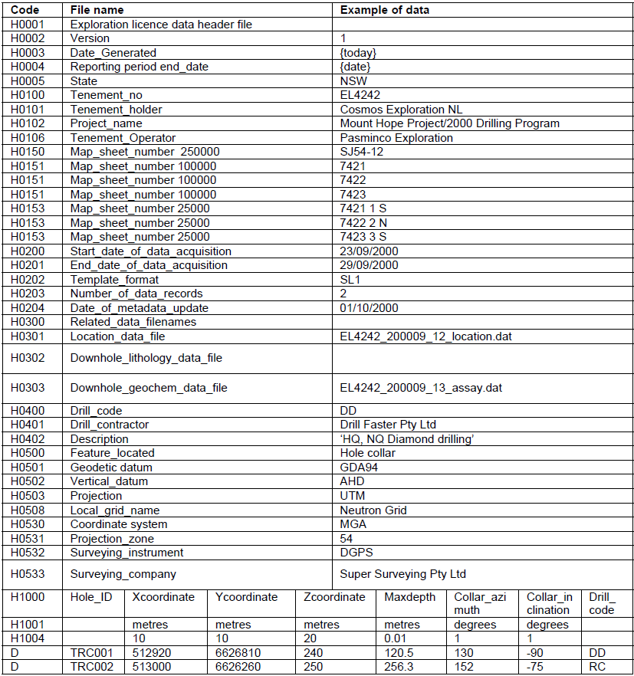

Example of surface geochemistry (SG1)
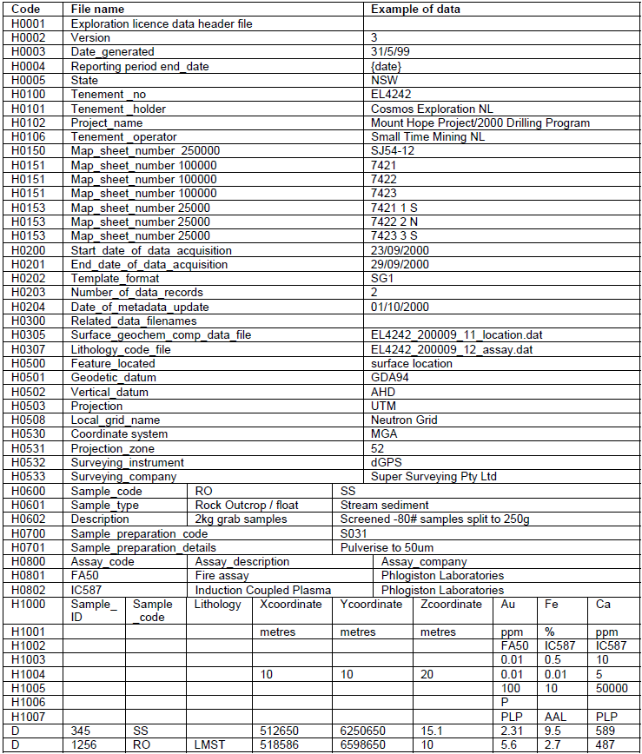

Example of geochemistry without locations* (SG2)
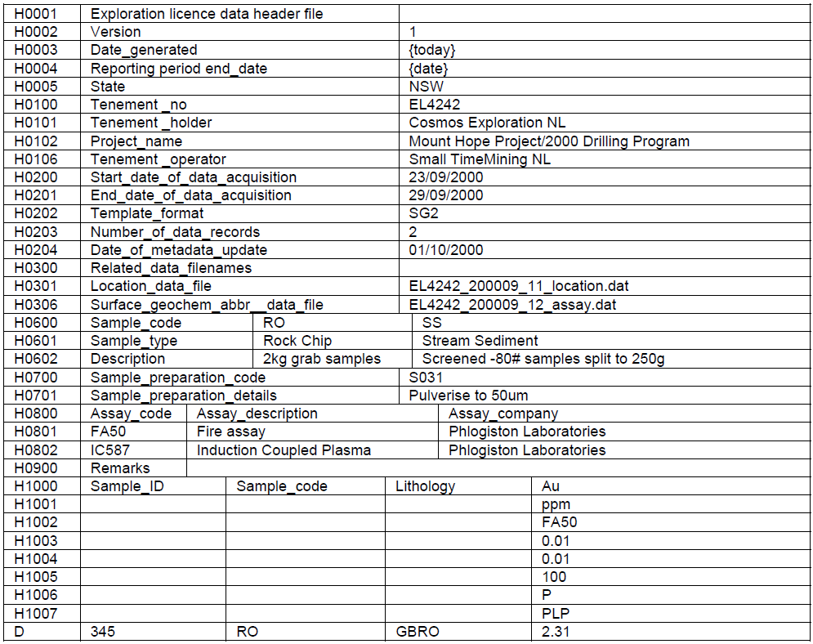

*If locations are not provided in this file, they must be included in a separate Sample Location file.

Example of drilling results (DS1)
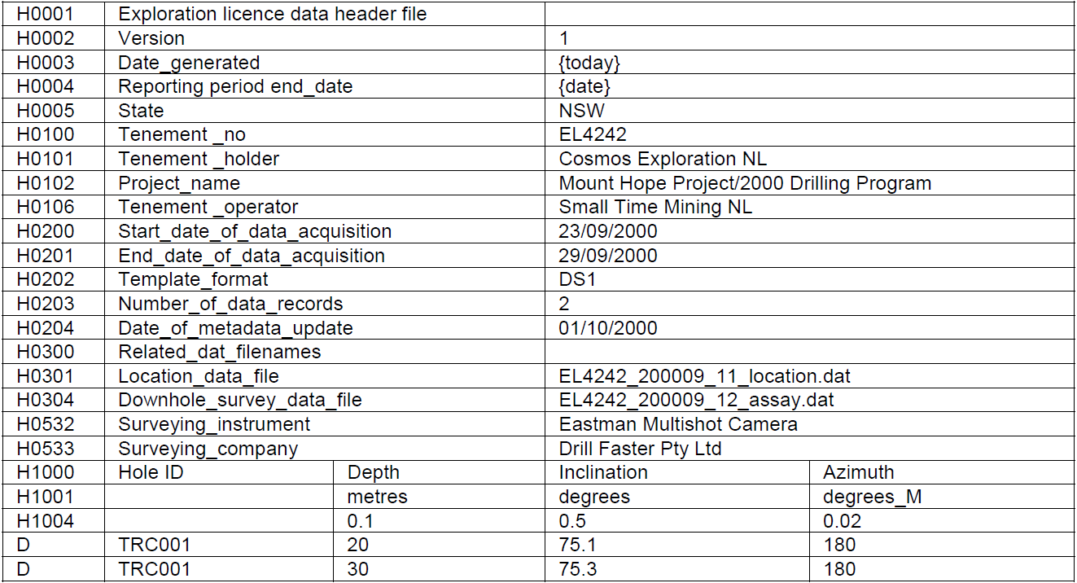

Example of lithological logging (DL1)
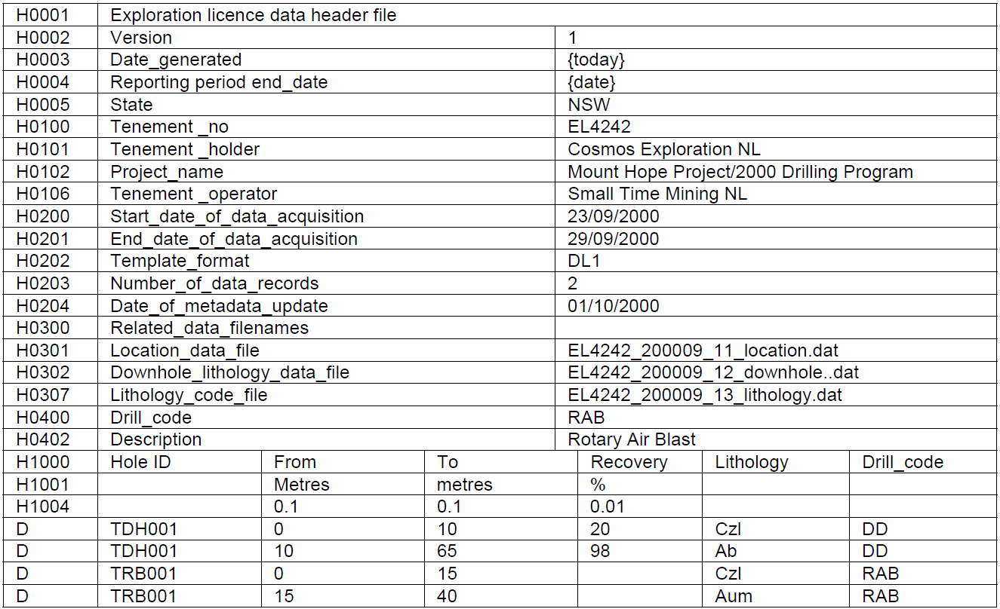

Example of down-hole geochemistry (DG1)
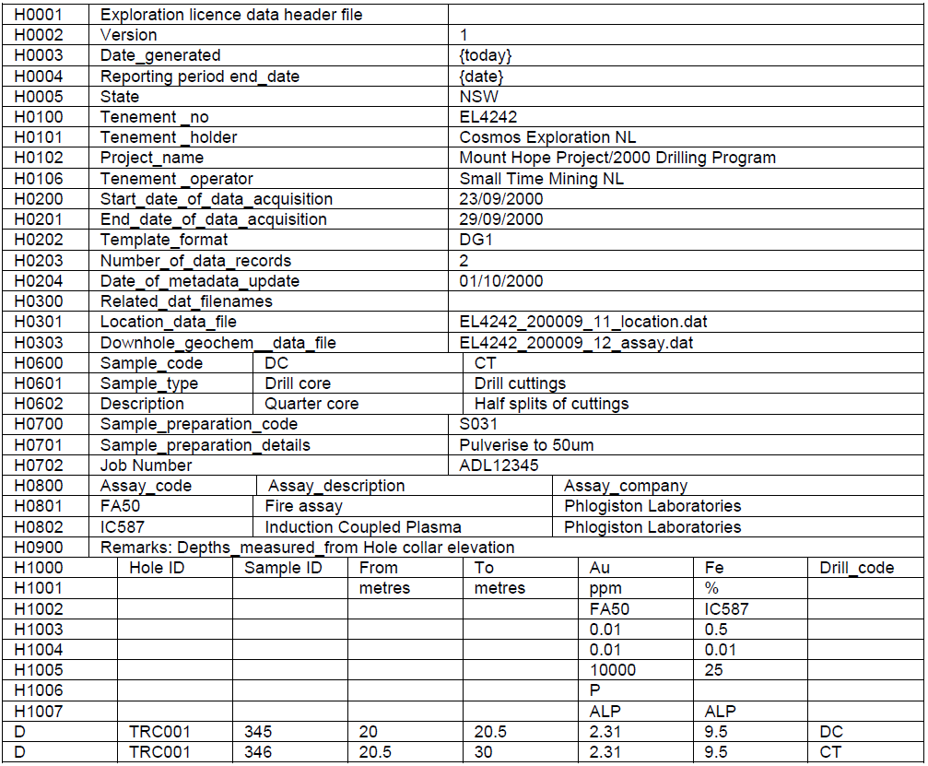

Example of QA/QC file for geochemistry (QG1)
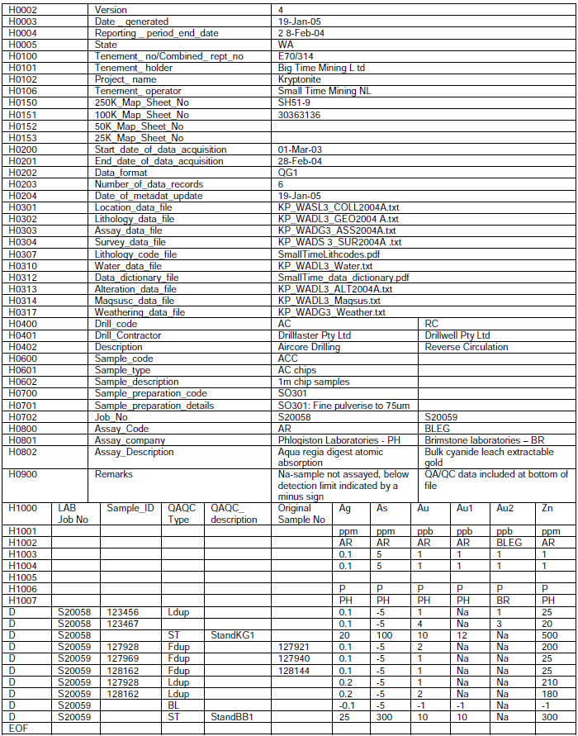

- Data formats for coal (Group 9)

Coal borehole summary table
A Coal Borehole Summary Table must be filled out and accompany the report for all boreholes completed during the reporting period only. If borehole data is being carried over to the next reporting period a Coal Borehole Summary Table must still be submitted and include boreholes drilled in the reporting period.

A Coal Borehole Summary Table must be submitted as a comma-delimited file (csv). This can be generated using the Microsoft Excel Spreadsheet Template. The Coal Borehole Summary Table Template is available from the department’s website:

http://www.resourcesandenergy.nsw.gov.au/miners-and-explorers/enforcement/exploration-reporting/coal

Coal borehole data
Any borehole exploration data acquired in the reporting period must be uploaded with the relevant report via EROL.

Data may include the following and be in the specified format:
1. Lithology Dictionary (comma delimited - csv). CoalLog standard dictionary required.
2. Lithology (comma delimitated – csv). CoalLog standard encoding required.
3. English Log (PDF)
4. Graphic Log, 1:200 scale (PDF or JPG)
5. Coal Quality Data (comma delimited - csv)
6. Downhole Wireline Logs (LAS files)
7. Downhole Acoustic Scanner Data – interpreted images (PDF or JPG)
8. Core Photographs (JPG or high resolution PDF).

Data for each hole must be submitted in individual ZIP files and must not exceed 32Mb. If ZIP files exceed 32Mb, additional ZIP files for a borehole can be submitted and labelled parts A, B, C etc. Files within each borehole ZIP file must be named accordingly. An example of how data should be formatted and how files should be named are provided in Table 4. Within borehole ZIP files there can be folders, however there must not be ZIP files within ZIP files.

CoalLog standard
‘CoalLog’ is the Australian coal logging standard, which aims to standardise the formats, dictionaries, definitions, and transferal conventions of coal borehole data in Australia. The standard was formally delivered to the coal industry in February 2012, with several updated versions subsequently released. Further information, and the latest versions of templates and dictionaries may be found on the AusIMM website:
https://www.ausimm.com.au/content/default.aspx?ID=451
The GSNSW has adopted the standard and requires authority holders to provide coal exploration data in the 'CoalLog' format.
Lithology logs must be submitted in comma or tab delimited ASCII text format as either individual data files, or as one single data file which contains a column specifying the borehole name. Borehole names must match those provided in the Coal Borehole Summary Table.

Regional geophysical data (seismic, magnetic, gravity)
Geophysical data that is not derived from down-hole surveys should be reported with the relevant annual report and the associated digital data supplied as set out in Part D(1).
Table 4 Coal data format example
Document Description | Format | Contents of Zip | File type
EL1111 Annual Report October 2016 | PDF | N/A | N/A
EL1111 Coal Borehole Summary Table October 2016 | CSV | N/A | N/A
Maitland DDH1 Data A | ZIP | Maitland DDH1 Lithology | (csv)
 |  | Maitland DDH1 Graphic log 1:200 | (pdf or jpg)
 |  | Maitland DDH1 English log | (pdf)
 |  | Maitland DDH1 Coal quality | (csv)
 |  | Maitland DDH1 Geophysics - Density | (LAS)
 |  | Maitland DDH1 Geophysics - Neutron | (LAS)
 |  | Maitland DDH1 Acoustic Scanner | (pdf or jpg)
 |  | Maitland DDH1 Core photo 1 | (jpg)
 |  | Maitland DDH1 Core photo 2 | (jpg)
Maitland DDH1 Data B | ZIP | Maitland DDH1 Core photo 3 | (jpg)
 |  | Maitland DDH1 Core photo 4 | (jpg)
 |  | Maitland DDH1 Core photo 5 | (jpg)
 |  | Maitland DDH1 Core photo 6 | (jpg)
 |  | Maitland DDH1 Core photo 7 | (jpg)
 |  | Maitland DDH1 Core photo 8 | (jpg)
Maitland DDH2 Data | ZIP | Maitland DDH2 Lithology | (csv)
 |  | Maitland DDH2 Graphic log 1:200 | (pdf or jpg)
 |  | Maitland DDH2 English log | (pdf)
 |  | Maitland DDH2 Coal quality | (csv)
 |  | Maitland DDH2 Geophysics - Density | (LAS)
 |  | Maitland DDH2 Geophysics - Neutron | (LAS)
 |  | Maitland DDH2 Geophysics - Gamma | (LAS)
 |  | Maitland DDH2 Acoustic Scanner | (pdf or jpg)
 |  | Maitland DDH2 Core photo 1 | (jpg)
 |  | Maitland DDH2 Core photo 2 | (jpg)
EL1111 Maitland JORC Resource and Reserve Statement October 2016 | PDF | N/A | N/A

Part F: Reports for small-scale titles

Opal prospecting licences
Opal prospecting licences are granted for a period of either 28 days or 3 months over designated opal prospecting blocks at Lightning Ridge and White Cliffs. The licences are granted for the purpose of prospecting for opal by drilling and shaft sinking.

A report covering all prospecting done must be submitted at the end of the term of the licence.

A form has been prepared to aid in the preparation of these reports. An example of this form is contained in Part D of this Guide and additional copies are available from the Department.

One side of the form consists of blank columns for graphic logs of the results of all drilling or shaft sinking. The logs should show the depth to, and thickness of, each different rock type. All intersections of opal, whether precious or potch, should also be noted on the logs. The reverse side of the form has instructions on the preparation of a location map to be provided with the logs.

Opal prospecting licence reports are not required in digital form.

Explanatory notes for opal prospecting licence drillhole logs
General
The conditions of an opal prospecting licence require the holder to submit a satisfactory report on all prospecting conducted on the licence. The prospecting report should include the following.
- completed drillhole log sheet or sheets for all holes drilled (see details below).
- a plan or plans showing the location of all holes drilled or shafts sunk (see details below).

Once lodged, copies of these reports are placed on open file and are available for members of the public to view at the Lightning Ridge office or in DIGS on our website at http://www.resourcesandenergy.nsw.gov.au/miners-and-explorers/geoscience-information/services/online-services/digs. This system was developed in response to requests from miners who expressed concern at the waste and duplication involved in drilling areas that had already been drilled by previous operators.

Drillhole logs
The results of all drilling must be recorded on one or more copies of the drillhole log sheet (see the front side of this sheet). Make sure that the number of the opal prospecting licence (OPL) and the number of the opal prospecting block (OPB) are recorded along with the drilling and geological information as indicated on the form. The logs should show the depth to, and thickness of, each different rock type. All intersections of opal, whether precious or potch, should also be noted on the logs.

Blank drillhole log sheets are available at the department’s Lightning Ridge office.

Plans
A suitable plan or plans showing the location of all drillholes must accompany completed drillhole log sheets. If more than one driller has operated on a licence, it is suggested that each driller submit a single plan to cover all holes drilled by that person.

The following details must be included on the plans submitted with the drillhole log sheets.
- arrow indicating the direction of north (specify whether magnetic north (MN) or true north (TN) is used)
- boundary of opal prospecting block
- main roads/tracks, fences, tanks, bores, opal fields, survey marks, 140 m contour (boundary between red and black soil)
- location and number of each hole (or group of holes) shown in relation to tracks, opal fields, etc. Where holes are drilled away from readily identifiable features then a general bearing and distance from those features should be indicated on the map for example, 500 m south west of bore.

Submission of reports
Prospecting reports should be lodged with the Mining Registrar at the relevant district office of the department.

