Emergency planning
- AIM: The aim of this program is to develop an emergency response plan and procedures to prevent further injury to people, damage to property or the work environment, in the event of an unplanned incident.
- WHAT: Our emergency response plan will consist of:

Procedure
Date: | Location:
Time:
Form 9A Emergency response plan
Incidents identified |  | Yes/No
Fire
Medical injury

Site plan
Date: | Location:
Time:
Form 9C Diagram showing equipment to be used during the management of an emergency
Equipment identified |  | Yes/No
Work and storage areas
First aid locations
Emergency muster points
Communication points (UHF, phone etc)
Fuel and chemical storage
Firefighting equipment
Access and egress points
Fixed plant
Emergency phones

Letter to emergency services
Send a letter or email to local emergency services to notify them of your existence/location and a copy of the site procedure and plan is to be sent with this letter.
Date sent:
How sent: (eg email, hard copy)
Form 9A Letter for emergency services
Person responsible for this letter:

First aid personnel
Date: | Location:
Time:
Form 9D First aid training

Warning systems
In an emergency, people on site will be alerted to the emergency via the use of the warning/alarm system, which is:
Type of warning system | Location

Withdrawal conditions
Emergency assembly point location:
Person responsible for taking visitor’s book (Section 13 of the SMS) to the emergency assembly point:

- WHO: The emergency response plan and procedure have been developed by _______________________ (nominated person) after consultation with the workforce and local emergency services
- HOW: Our mine has identified its potential emergencies using a risk-based approach. Consultation has taken place with the workers and where possible relevant emergency services. After this consultation Form 9A and Plan 9C have been formulated. The emergency procedure and plan will be communicated to the workforce through our induction program and safety meetings. Training in the use of emergency equipment, such as first aid or firefighting equipment will be conducted through Program 14 Training.
Task to be completed | Date completed
Form 9A Emergency procedure
Form 9C Diagram showing equipment to be used during the management of an emergency
Communicate to workforce
Training
- WHEN: To ensure that the procedure can deal with emergencies, an emergency drill should be carried out. All workers will be made aware of the emergency plan during their induction and during the annual review conducted as part of the yearly safety plan (Program 1).
Emergencies | Date
Emergency drill
- ACTION: Train all employees and contractors in the use of the procedures. This should be recorded in your
- DOCUMENT CONTROL: Emergency procedures and the site plan will be recorded on the Document control master list (Form 3A). Originals are to remain part of this SMS.

Form 9A: Emergency procedure
In the event an emergency
KEEP CALM
DIAL 000 or 112(mobile)
- Tell the operator which service you require and provide them with the site’s details.
- If possible send a person to the front gate to direct Ambulance or Emergency Services.
Address: _______________________________________________________
Nearest cross road: ______________________________________________
Contact name: __________________________________________________
Contact number: ________________________________________________
Further information: ______________________________________________
GPS coordinates Lat: ___________________ Long: ____________________
Ambulance phone: ______________ Fire brigade phone: ________________

FIRE |  | MEDICAL |  | OTHER
Type of fire |  | Number of people injured
Size of fire |  | Type of emergency
Ensure people are accounted for |  | Injuries
If safe, remove all plant from the area |  | Ensure area is safe before giving help
Contact management |  | Contact management
Only attempt to extinguish fire if safe |  | Once area is safe complete DRSABC and give help
Isolate mobile plant for 24 hours |  | Send escort for emergency services
Preserve the scene |  | Preserve the scene
Contact the regulator | 1300 814 609 | Contact the regulator | 1300 814 609
Investigate (program 12) |  | Investigate (program 12)

REMEMBER
QUICK RESPONSE CAN SAVE LIVES

Form 9B
Date: __________________

_______________________________
_______________________________
_______________________________

Dear Officers,

I am writing this letter to inform your station of an extractive industry we are operating within your station zone.

The attached page lists the following information:

- name of operation and manager
- type of operation
- written directions to the operation, a map and site plan
- contact telephone numbers and names
- extraction taking place and number of workers
- plant and equipment used to win and process the product
- the maximum number of persons that may be on site at the time of an emergency
- equipment on site to assist in the event of an emergency

The site is open ________________________________. When open, the hours of operation are ___________________ to ___________________.

We would also like to extend an invitation to all station officers to visit the site for an inspection of the operation and review emergency procedures.

We hope this information may assist officers in the event of an emergency and look forward to further communication with your station.

I may be contacted by telephoning ________________________ for further information or to arrange a site visit.

Yours sincerely,

DETAILS OF QUARRY OPERATIONS
Mine operation name
Type of operation | Surface open cut | Underground
 | Processing plant | Other:
LOCATION DETAILS
Street and number
Suburb/town
Nearest cross road
GPS coordinates | Lat: | Long:
CONTACTS
Primary contact |  | Phone:
Secondary contact |  | Phone:
After hours contact |  | Phone:
Maximum number of people on site
DETAILS OF WORK UNDERTAKEN (including number of workers)
PLANT & EQUIPMENT ON SITE
CHEMICALS / FUELS / EXPLOSIVES ON SITE
EMERGENCY EQUIPMENT ON SITE
OTHER INFORMATION
Name | Signature | Date

Form 9C Site emergency plan
Draw your site emergency plan here:
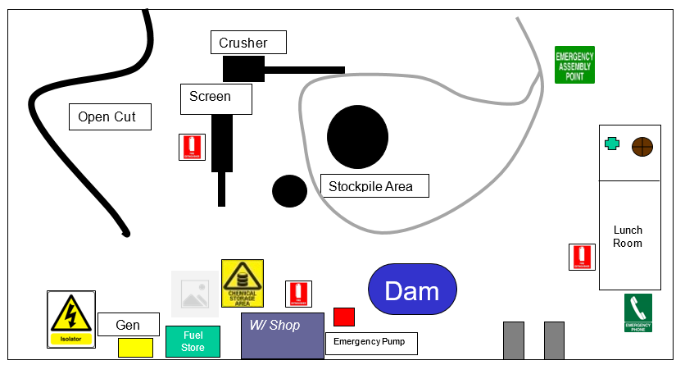
Form 9D First aid officers
Name | Qualification | Date issued | Expire date

